# CS 255 System Design Document Template

This template lays out all the different sections that you need to complete for Project Two. Each section has guidance to prompt your thinking. You will need to continually reference the interview transcript as you work to make sure that you are addressing your client’s needs. There is no required length for the final document. Instead the goal is to complete each section based on what your client’s needs are. Remove this note when you are finished, and replace all bracketed text with the relevant information.

## UML Diagrams

### UML Use Case Diagram

### UML Activity Diagrams

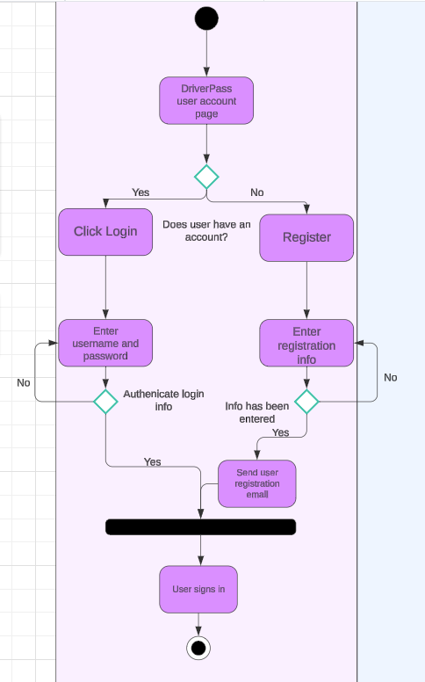

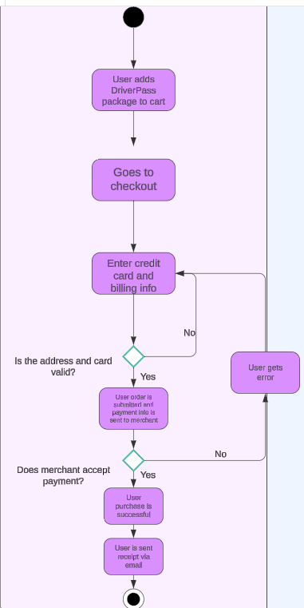

### UML Sequence Diagram

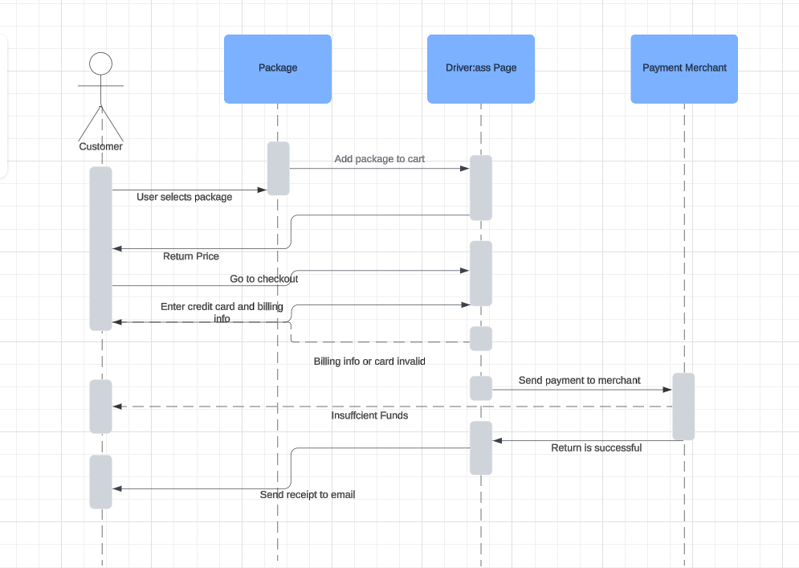

### UML Class Diagram

## Technical Requirements

Hardware:

* Server to host the application and database.
* Network connection
* Computer and/or mobile devices
* Storage

Software:

* Windows or Linux servers
* SQL server to handle product, order, and user data.
* Software security
* Web server go manage requests and deliver web content.

Tools:

* GitHub or GitLab for code management and collaboration.
* Services like New Relic or CloudWatch to monitor system performance.

Infrastructure Requirements:

* Stable internet connection
* Firewalls and VPNs to secure data transmissions
* Cloud platforms like AWS or Azure
* Role based access control to protect business and customer data.